VEHICULAR SECURITY SYSTEM BY
Md. Najmus Sayadat
ID: 151-15-4916
And
Arijit Banarjee
ID: 151-15-5417

This Report Presented in Partial Fulfillment of the Requirements for the Degree of Bachelor of Science in Computer Science and Engineering

Supervised By

Dr. Farnaz Narin nur Assistant professor Department of CSE
Daffodil International University Co-Supervised By
Ms. Nazmun Nessa Moon Assistant Professor Department of CSE
Daffodil International University



DAFFODIL INTERNATIONAL UNIVERSITY DHAKA, BANGLADESH
10TH DECEMBER 2018

APPROVAL
This Project titled “Vehicular Security System”, submitted by Najmus Sayadat, ID: 151-15-4916 and Arijit Banarjee, ID: 15-15-5417 to the Department of Computer Science and Engineering, Daffodil International University, has been accepted as satisfactory for the partial fulfillment of the requirements for the degree of B.Sc. in Computer Science and Engineering and approved as to its style and contents. The presentation has been held on 10TH December 2018.

BOARD OF EXAMINERS

Dr. Syed Akhter Hossain Chairman
Professor and Head
Department of CSE
Faculty of Science & Information Technology Daffodil International University

Narayan Ranjan Chakraborty Internal Examiner Assistant Professor
Department of CSE
Faculty of Science & Information Technology Daffodil International University

Md. Tarek Habib Internal Examiner
Assistant Professor Department of ------- Jahangirnagar University

Dr. Mohammad Shorif Uddin External Examiner Professor

Department of Computer Science and Engineering Daffodil International University.

DECLARATION

We hereby declare that, this project has been done by us under the supervision of Dr. Farnaz Narin Nur, Assistant Professor, Department of CSE Daffodil International University. We also declare that neither this project nor any part of this project has been submitted elsewhere for award of any degree or diploma.

Supervised by:

Dr. Farnaz Narin Nur Assistant Professor Department of CSE
Daffodil International University

Co- Supervised by:

Ms. Nazmun Nessa Moon Assistant Professor Department of CSE
Daffodil International University

Submitted by:

Najmus Sayadat
ID: 151-15-4916
Department of CSE
Daffodil International University

Arijit Banarjee
ID: 151-15-5417
Department of CSE
Daffodil International University

ACKNOWLEDGEMENT

First, we express our heartiest thanks and gratefulness to almighty God for His divine blessing makes us possible to complete the final year project/internship successfully.

We really grateful and wish our profound our indebtedness to Dr. Farnaz Narin Nur, Assistant Professor, Department of CSE Daffodil International University, Dhaka. Deep Knowledge & keen interest of our supervisor in the field of “IOT” to carry out this project. His endless patience, scholarly guidance, continual encouragement, constant and energetic supervision, constructive criticism, valuable advice, reading many inferior drafts and correcting them at all stage have made it possible to complete this project.

We would like to express our heartiest gratitude to Dr. Farnaz Narin Nur, Assistant Professor and Prof. Dr. Syed Akhter Hossain, Head, Department of CSE, for his kind help to finish our project and also to other faculty member and the staff of CSE department of Daffodil International University.

We would like to thank our entire course mate in Daffodil International University, who took part in this discuss while completing the course work.

Finally, we must acknowledge with due respect the constant support and patients of our parents.

ABSTRACT

The main purpose of the “Vehicular security system” is to make a better solution for vehicle and user safety. These devices are very essential for the people who are driving or travelling in road. Our system compares all the data and give suggestion base on the feature which attempt is danger, maintain minimum traffic rules and mostly user safety. To develop this project, we use robotics system. After implementation of all functions, the system is tested in different stages and it works successfully as a prototype. We can also use our project for autopilot driving, safety braking system, prevent accident, increase driving safety on road and many type of use.

The main feature of our project to increase driving safety and ensure driver security for better driving. This project helps us to make an advance driving system. In future we add some extra feature like user location tracking, driving alert, source to destination shortest path, speed lock and more. Thus, our project helps us to make a digital Bangladesh in the present situation.

TABLE OF CONTENTS

CNTENTS
PAGE
Board of examiners Declaration Acknowledgements Abstract  CHAPTER-1: INTRODUCTION | (1-2) | i ii iii iv
1.1 Introduction of Recommendation system |  | 1
1.2 Motivation |  | 1
1.3 Objective |  | 1
1.4 Expected Outcome |  | 1
1.5 Report Layout  CHAPTER- 2: BACKGROUND | (3-5) | 2
2.1 Introduction |  | 3
2.2 Related Works |  | 3
2.3 Comparative Studies |  | 4
2.4 Scope of Problem |  | 5
2.5 Challenges  CHAPTER-3: Requirement Specification | (6-10) | 5
3.1 Business processing Model |  | 6
3.2 Requirement Collection & Analysis |  | 7

3.3 Use case modeling and Description | 7
3.4 Logical data Model | 8
CONTENTS | PAGE
3.5 Entity Relationship Diagram (ERD) | 8
3.6 Design Requirement | 9
3.7 Data flow diagram | 10
CHAPTER-4: DESIGN SPECIFICATION | (11-13)
4.1 Sensor Design | 11
CHAPTE- 5: IMPLEMENTATION & TESTING | (14-15)
5.1 Sensor implementation and testing | 14
5.2 Test results and report | 15
CHAPTER-6: CONCLUSION AND FUTURE SCOPE | (16)
6.1 Discussion and Conclusion | 16
6.2 Scope for Further Developments | 16
REFERENCES | 17
APPENDIX | 18

LIST OF FIGURES

FIGURE | PAGE NO
Figure 2.1: Road Lane detection | 3
Figure 2.2: Traffic and traffic lane detection | 4
Figure 3.1: Business Process Model | 6
Figure 3.2: Use Case Model | 8
Figure 3.3: Entity Relationship Diagram | 9
Figure 3.4: Data Flow Diagram | 10
Figure 4.1: Car with Ultra-sonic Sensor | 11
Figure 4.2: A car in front of our car | 12
Figure 4.3: If a car is on left | 12
Figure 4.4: A car with right side | 13
Figure 4.5: A car with front and right side | 13

CHAPTER 1

Introduction

  - Introduction to Recommendation system

Technology is smarter day by day. By using these technologies, we can make our life smarter. There are some technologies that make our life faster and easier. In these circumstances we are going to make a smart device that can give extra security for driving on road. In our country many people died by accident. This accident causes a big lost our economy, people lives and many things. To prevent the accident, we are going to make a system that’s increase the driving safety. This system makes an alert to prevent accident.

Motivation

Vehicular accident is a common problem in Bangladesh. Recently, some new technologies like providing new application which make our lives smarter and easier. In the state we found some project to control accident using smart technologies. Using Internet of Things (IOT) and Artificial Intelligence (AI) to develop a system so that we can easily prevent our accident and vehicular safety. Hence in Bangladesh this type of project will be a new invention for making a digital Bangladesh.

Objective

    - Driving security system
    - Prevent road accident
    - Driver safety
    - Detect vehicle
    - Automated alert for driving

Expected Outcome

- A secured Design for user safety,

- Better vehicular control

- Driver security system

- Better visual and sound alert

Report Layout

Chapter 1: Introduction

In this chapter we have discussed about the motivation, objectives and the expected Outcome of the project. Later followed by the report layout.

Chapter 2: Background

We discuss about the background circumstances of our project. We also talk about the related work, comparison to other candidate systems, the scope of the problem and Challenges of the project.

Chapter 3: Requirement Specification

This chapter is all about the requirements like business process modeling, the Requirement collection and analysis, the use case model of the project and their Description, the logical relational database model and the design requirements.

Chapter 4: Design Specification

In this chapter all the designs of the project. Sensors design and specification the implementation requirements.

Chapter 5: Implementation and Testing

This chapter contains the implementation of sensor, Data flow diagram designs and interactions and the test results of the project.

Chapter 6: Conclusion and Future Scope

We discussed about the conclusion and the scope for further developments which pretty much derive about the project.

  - Introduction

CHAPTER 2

Background

To start a project, we need to concern about many things. Background of the project is more important issue to complete the project very nicely. To start a project, we need to study about many more subject which will be related or not related with the topic. We need to fix the areas in which we will work. To build a good project study is must. So we need to research about the related sectors and also find out the similar work. From the similar work we will find out our target and features of the project. To estimate the scope of problem we can ensure that what problem we will faced. So background of any project is most important thing to build up a successful project.

Related Work

We found some vehicle company who are created this advance technology in premium segment vehicles. Example: Tesla Figure 2.1 [2] including source code [5], Land rover [9], Volvo [6], Mercedes is trying to make their auto pilot driving [8]. In the Figure 2.1 we see that Tesla use a sensor to detect the road lane. By detecting road lane, it can take a diction for autopilot driving mode.

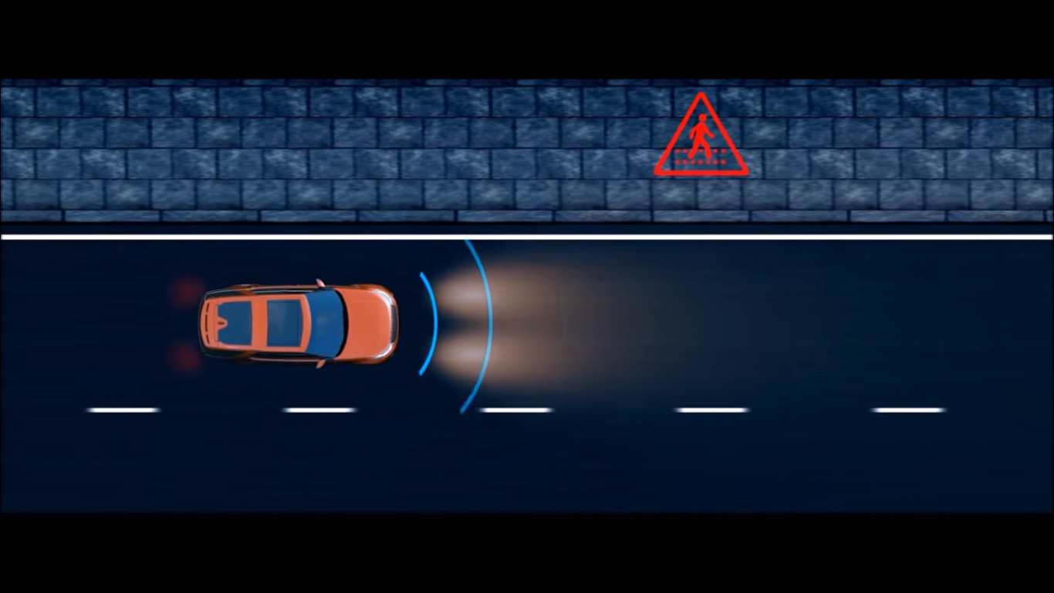

Figure 2.1: Road lane detected

In the Figure 2.2 we see that Tesla use a sensor to detect road side vehicle. By detecting the vehicle it can take a diction for is it turn to left or right or brake. This sensor help a car to get the diction by measuring the distance from road side vehicle. The top speed of the Tesla car using autopilot driving mode to 70km/h.
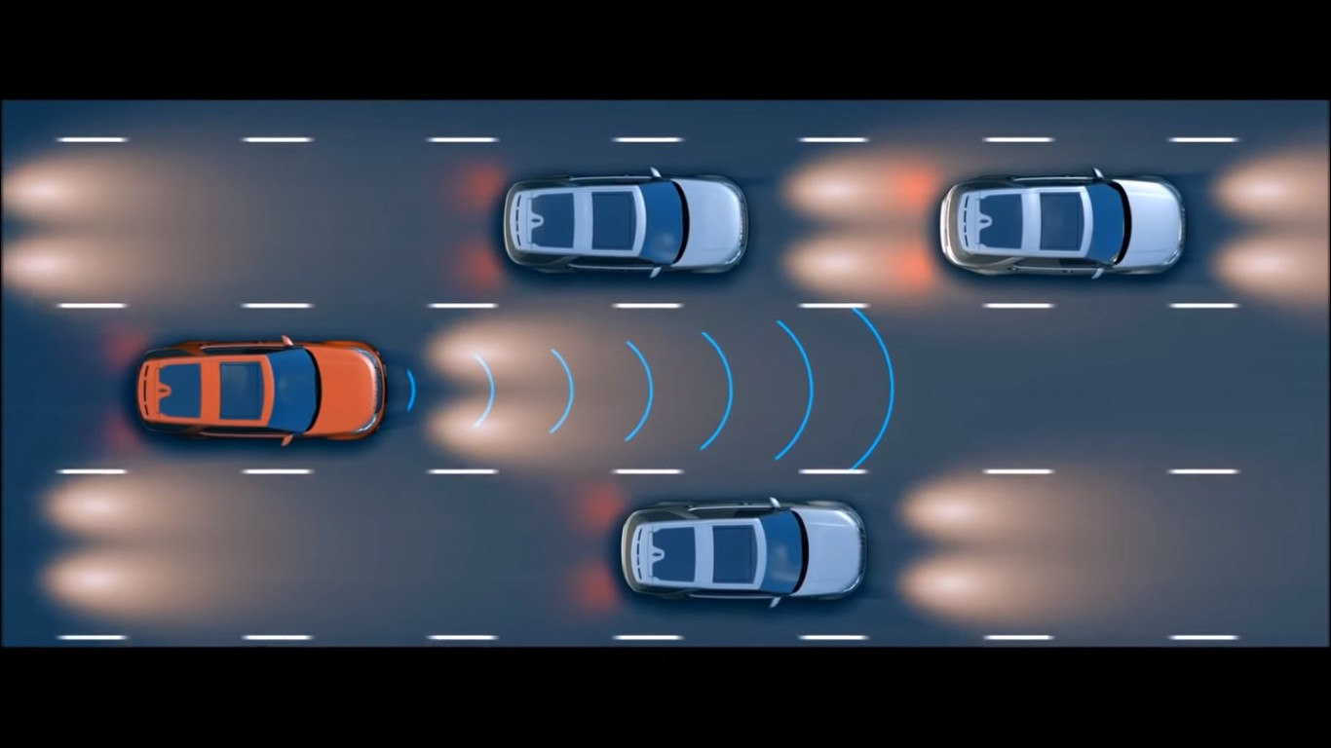
Figure 2.2: Traffic and traffic lane detection.

Comparative Studies

The Land rover is going to make a project 2019 in discovery model which includes proper car detection, lane detection Fig: 2.1 and Fig: 2.2, automated steering as a safety feature, and automated braking alert system using light beeping [9]. But in 2018 model they got only automated object detection by using light.
Tesla are giving Amazing Autopilot System of Elon Musk [10] design more attraction for traffic rules, user safety, automated parking system and distance measurement but the price is $79500 in USA and there is no tesla solar charging station in Bangladesh.
By distance measurement Volvo use antilock braking system. This system alert user for braking and make also automatic brake too by using distance measurement. But there is many complain report of automatic braking system doesn’t work properly [11, 12].

Scope of problem

To complete this project, we face many problems. There are some problems which are more difficult and some problem which are little bit easy. After solving all problem, we develop this system. The problems which we faced to develop this system is given below:
    - We have to know real body length and wide of vehicles and roads.
    - We have to talk with agent that they are interested or not to work with us.
    - We have to learn about traffic rules.
    - We have to make user believe properly with proper information and opportunities.
    - The main problem of our project is collect data.
    - We have to find real data.

Challenges

Our project should have some challenges to make it different to provide a better service:
    - Attractive design and useful features
    - Giving information about objects distance
    - Ensure security for user.
    - Better use for only traffic and driver safety.
    - Make the project very friendly to user.
    - Make coverage of 1 lane = 8.2 to 10.7 ft.

CHAPTER 3

Requirement Specification

Business Processing Model

Business process model Figure 3.1 is actually mapping concept. It is a tool for building a flowing diagram or model. BPM basically define the appropriate flow of data from the start to end. We can define the capability of the project. Every engineering project there will must need to develop a business model before start the project work. Business processing model helps us to give the client services in an efficient way. This model makes the project flexible to both user and developer.
A company or any organization is using the Business Model Diagram Figure 3.1 for graphical representation. There are many methods or regulatory body like flowchart, data-flow diagram etc. are used to represent the model. There are many kinds of Business Processing Model. Here we discuss about the process of adding new features

or solving the program error after realizing the project. Figure 3.1 BPM show how developers are with the system.
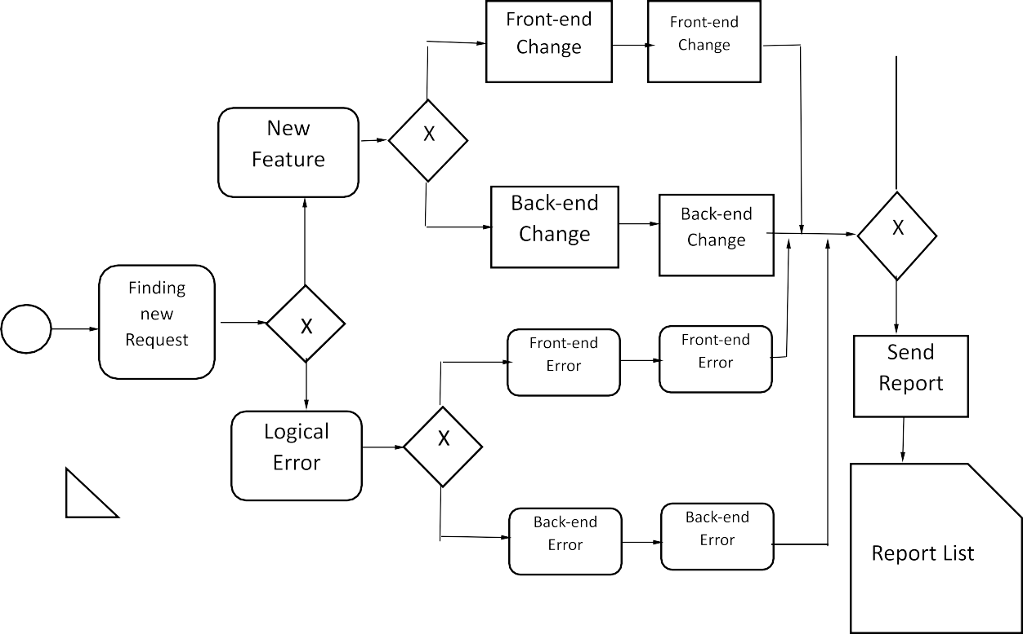
Figure 3.1: Business Process Model

Requirement Collection & Analysis

In every single project, initial work is specifying the necessary requirements and also collecting the requirement. Because without requirement we cannot draw a graphical view of a project. Graphical view is very important for a project to implement every single task. It is a bad practice to start a project without collecting the requirement first. On this project requirement collection is very big challenge for us. Because requirement for this project is not available everywhere. We need to communicate with the agent to know their working process. After knowing the working process, we need to specify the tools which we are use on our project. We divide our project into several part. Because several part of data we need to use here. On the basis of data, we collect the requirement. We specify what kind of users are use this system. After completing the requirement collection, we need to analysis the requirements. By analyzing we can prepare many method and model to represent the system. We can specify how the users complete their task through the system. Data moving is also set

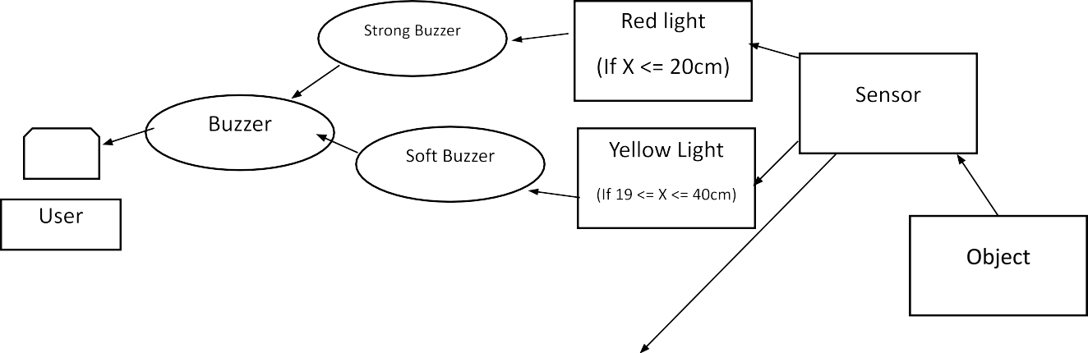
by analyzing the requirements. So, requirement and requirements analysis is very important for any project. To build a successful project need to collect the requirement first and then we need to analyze the requirement and specify the method for the project.

Use Case Modeling and Description

In Requirement Specification, a use case is a list of actions or every step, typically defining the interaction between a role (Known in the Unified Modeling Language as an actor) and a system, to an achieve a goal.
The actor can be a human or other external system. Use case model is the smartest way to represent a system. A developer can easily represent the system to the client in simplest way through use case modeling. A use case diagram at its simplest is a representative of a user’s interaction with the system that shows the relationship between the user and the different use case in which the user is involved. So to create use case model, the analyst must first identify the different types of user who use the system. These actions actually represent the procedures; which people have to follow to operate the system. Use case describes scenarios that will be perceived differently by different actors. Our system is so complex. As a result, we do the use case part by part according to ER diagram or schema diagram. Figure 3.2 shows use case for user admin, Figure 3.2 show the use case. Shows use case for user.

Figure 3.2: Use case Model

Logical Data Model

Logical data model is diagram by which we can represent the activity of a system data. How logically the data can move through the system and the reaction of the systems with the data is represented by this kind of model. Some Logical Data model for this system is given below:

Entity Relationship Diagram (ERD)

An ER diagram (Figure 3.3) is a means of visualizing how the information a system produces is related. There are five components of ERD. Entity, Weak Entity, Relational, Attribute, Multivalued attribute, Derived attribute. With the help of these five components Entity Relationship Diagram is drawn. In out ERD we are using these components. A basic ERD model is composed of entity types and specifies relations that can exist between instances of those entity types. Figure 3.3 shows the Entity Relationship Diagram for our project.

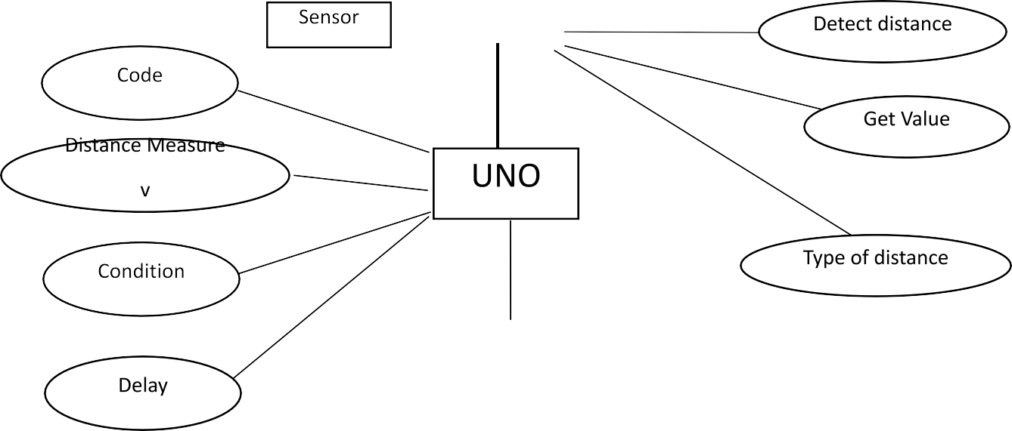

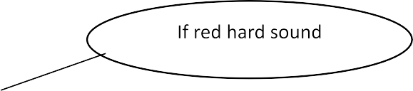
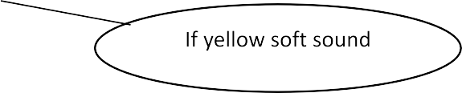
Figure 3.3: Entity Relationship Diagram (ERD)

Design Requirement

    - This system has four ultrasonic sensor which measure the distance
    - One buzzer which give an alert for low distance traffic
    - There three notification light which notify user for traffic
    - When no traffic in around the vehicle there is green light active.
    - If any vehicle is nearby user vehicle the yellow signal is active
    - If any vehicle is closed to user vehicle the red signal is active

Data flow diagram

We use data flow diagram Figure 3.4 to represent the whole system of our project testing. In the diagram first ultrasonic sensor detect the distance. Then it sends to the system for description. By measuring the distance, the system takes three dictions. One is if the distance is larger than 40cm then it provides green light and no buzzer, if the distance is less than 40 and greater than 20 then it provides yellow light and give a simple buzzer and less than 20 the red light is on and it give strong buzzer.

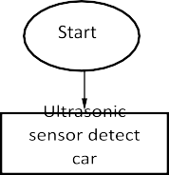
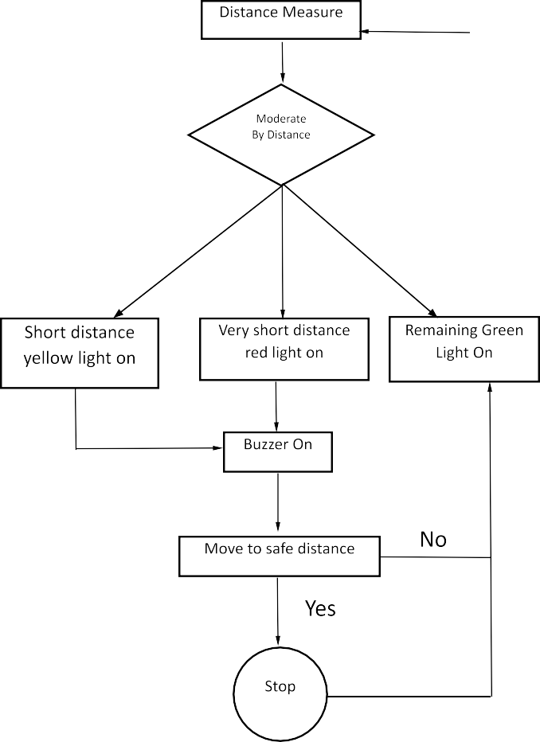
Figure 3.4: Data flow diagram

CHAPTER 4

Design Specification

Sensor design:
We use three sensors of ultra-sonic. Which will be in front side of the vehicles. Each ultra-sonic has a range with 300 c.m. / 3 m. it will take a place in the front side (Figure 4.1) of car or bike and one is. But in bike it will need only one sensor.
In car the average front wheel base wide is 6 or 7 feet. so, I put my sensors at 3 or 4 feet’s and put my sensors in 50 degrees for get 3 angles views,
    - Front left

    - Front right
    - Front

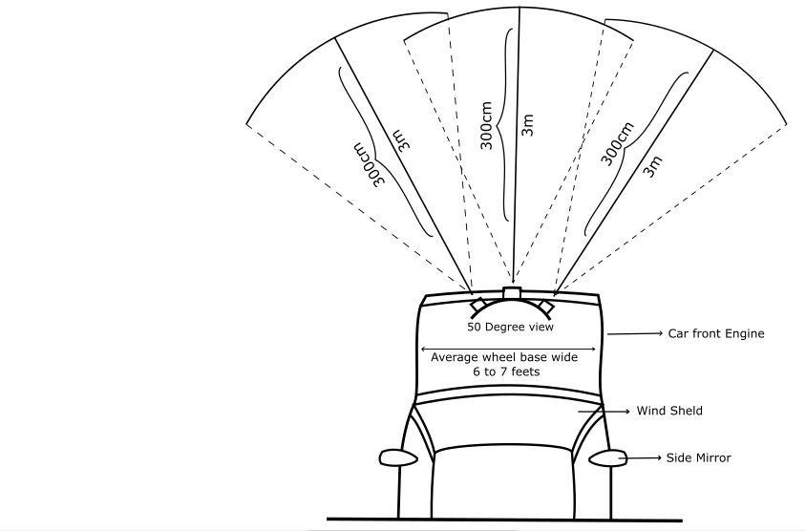
It is mainly a safety feature in this project. There are many situation happen during driving any vehicles. At first when we see on our project.
Figure 4.1: car with ultra-sonic sensor

In Figure 4.1 and Figure 4.2, it will stand in front of the car engine and will be angle in 50 degrees. So, if it face real problem like some car in front of our car when it will come in our diameter it will show and shout the buzzer. The average car wheel base wide is 6 to 7 feet and sensor cover average 8 to 9 feet.

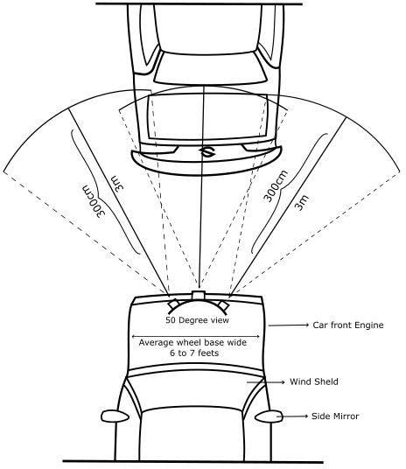

Figure 4.2: a car in front of our car.

In Figure 4.3, it will also show if in your left if u have a car is it safe to drive or you need to stop.
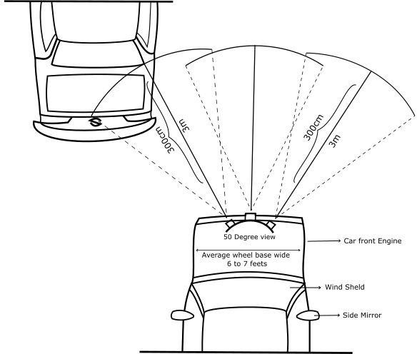

Figure 4.3: if a car is on left

In Figure 4.4, if we have incoming car of our front, it will also measure the right side of distance with ours and tell us to stop too if it is danger.
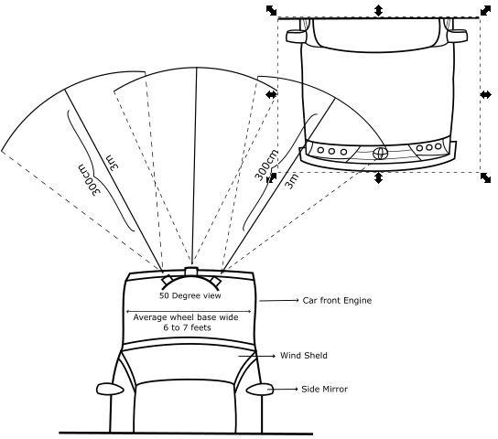

Figure 4.4: A car with right side.

In Figure 4.5, if we have a car in front and a car is also coming in right side toward us, sometimes drivers are overtaking with taking high risk. Here also our device can tell what we need to do.
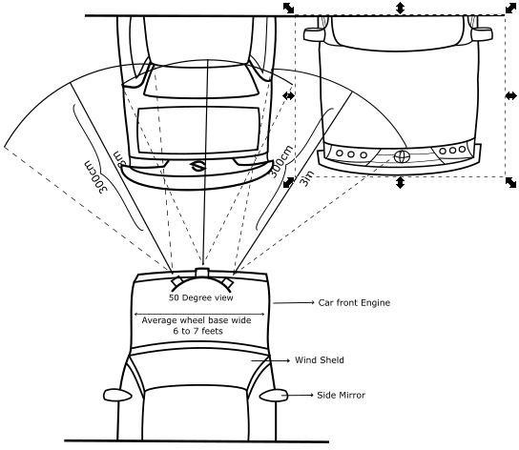

Figure 4.5: car with front and right side.

CHAPTER 5

Implementation and Testing

Sensor Implementation and Testing

Ultra – sonic sensor is an analog input sensor. All sensor are connected in breadboard in series line pins, trigger and eco pin are also in connected in series lines. And it put in arduino in pin which is analog. All sensors and arduino needs 5v for run which is run by a 5v power source. We use three light that can help a user to give a distance signal. We also use buzzer to give an audio signal.
Here we can see that trigger pin is output and eco pin is input. But we here made testing on our sensor is it works perfectly.
Here is the testing of 3 sensors data which is connected and give the data simultaneously in every 1 second. And if we block the sensor one of them .It has been shown us in below table.

  - Test results and report:

Test Case | Test Input | Expected outcome | Obtained outcome | Pass / fail | Tested on
1.  Distance test | Leave the sensor for read data | Successfully read | Successfully read | Pass | 9-10-2018
2. Object detection test | Leave the sensor for read  object | Successfully read | Successfully Read | Pass | 9-10-2018
3 light checking with  distance | Insert light with resistance | Successfully lighted | Successfully Lighted | Pass | 4-11-2018
4 Buzzer Sound checking with  distance | Insert Buzzer | Successfully sounded | Successfully Sounded | pass | 4-11-2018

CHAPTER 6

Conclusion and feature scope

Discussion and Conclusion

We have successfully implemented the system “Vehicular security system” with the help of various links and tools. We have been successful in our attempt to take care of the needs of user safety. Finally, we hope that this will go a long way in popularizing the organization and making its work of enrollment.

Scope for Further Developments

Our system is to make a better security for driving on road and traffic. Our project helps us to giving a controlled traffic and ignore traffic rules violation. In the future we can make a better system to develop more the traffic system by this project. Our future work for this project:
    - Tracking user location
    - Make a better security system
    - Ignore traffic violation
    - Emergency help service
    - Live driving notification
    - Density measurement
    - Shortest path system

REFERANCES

- Learn about Volvo braking system, available at <<https://youtu.be/ridS396W2BY>>, last accessed on 06-12-2017 at 11:14pm.
- Learn about Tasla autopilot Driving system, available at <<https://youtu.be/a6KL2s5NJx0>>, last accessed on 24-12-2017 at 10:25am.
- Learn about VA-NET project reference: https://ieeexplore.ieee.org/document/7449188>>, last accessed on 11-01-2018 at 10:48am.
- Learn about Tesla autopilot driving project, available at
<<https://www.tesla.com/autopilot>>, last accessed on 15-01-2018 at 12:25pm.
- Learn about Tesla autopilot driving source code, available at
<<https://github.com/commaai/openpilot>>, last accessed on 25-01-2018 at 03:35pm.
- Learn about Volvo Truck Emergence Braking System, available at
<<https://youtu.be/sa6IXQoYY58>>, last accessed on 01-02-2018 at 04:20pm.
- Learn about Mercedes-Benz Actros Safety Truck - Active Brake Assist, available at
<<https://youtu.be/jSQSueFrxzI>>, last accessed on 12-02-2018 at 12:02am.
- Learn about Mercedes autopilot driving project, available at
<<https://youtu.be/XZxZC0lgOlc>>, last accessed on 04-05-2018 at 07:25pm.
- Learn about 2019 Land Rover Discovery, available at
<<https://www.youtube.com/watch?v=_hEPriIj8g8>>, last accessed on 06-06-2018 at 10:35am.
- Learn about 2018 Tesla Model X Full-Self Driving TEST DRIVE - Amazing Autopilot System of Elon Musk, available at <<https://youtu.be/0NtdZNWUBik>>, last accessed on 15-06-2018 at 08:32pm.
- Learn about Volvo automatic braking system fail, available at
<<https://youtu.be/_47utWAoupo>>, last accessed on 12-07-2018 at 07:09pm.
- Learn about Automatic braking system fail, available at <<https://youtu.be/o9O-aejD0vI>>, last accessed on 24-07-2018 at 02:25pm.

APPENDIX

Research Reflection

Our journey had started from fall 2017 to develop a system. On this project we try to prepare a smart solution for the recommendation. This system develops a relationship between user and vehicle. We use the latest technology and model to prepare this system. We tried hard to develop a system which create a revolutionary change in our country. Our system is a part of making Digital Bangladesh. Doing the all-necessary task, finally we met to the goal and complete our task. So it is our hope that our system “Vehicular security system” will create a communication bridge between IOT and user.

